**Test**

Namae :- Sanjeewa Wijaewardhana

Time :- 15 07

Place :- Kegalle

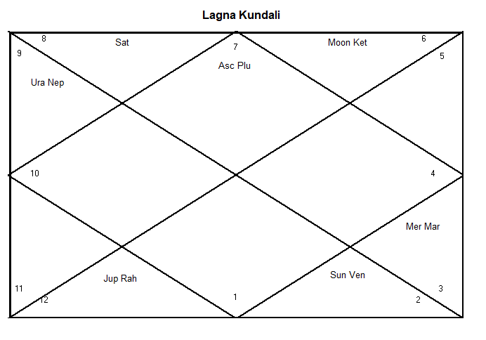

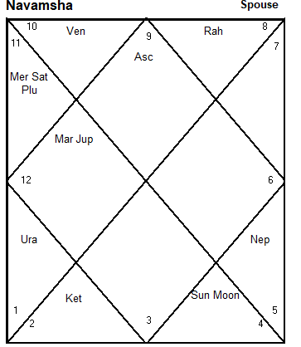

Libra (TULA lagna) Sagittarius (DANU Nvamsha)

**At glance :-**

1, First look This kendra has 4 House Empty it meaning one thing missing in Life ( hathara Kendra Dosha )

2. Rahu Jupiter Yoga

3. Kethu MOON yoga

4. 3 planet in grate Enemy

5, 3 planet in Friend

6. Any planet not Debilitated or Combust

7. Jupiter is Athma karaka

8 kalathra karaka is Venus

9. now Going Jupiter Dasha

10 Gajakeshari yoga

11 Vahana Yoga (vehicle )

12 Foreign Country reside Yoga

**Prediction (Correct point High light and Send to me back )**

1. Medium height 5.5 to 5. 8 , small teeth may be , teeth gap very small and sometimes get
2. Your older looking than your Age this is Wise versa
3. All ways laugh and not bother to others
4. You not again return thing in your work
5. 30 around age is remarkable
6. After 30 to 42 Golden age
7. After 65 You can accumulate wealth
8. Around 24 to 26 you get job or major change of the job
9. You have Young Sibling
10. You get some wealth your grandfather side
11. Your mother House wife may be or not Good earning
12. Your mother strongest than a father
13. Your father working as a mathematic teaching or Forces
14. You have Asma like systems like allege ( Cold ) and teeth problem
15. Your life UPS and Down most of the time
16. Accumulate of wealth p[problem some times
17. You mind can not understand others
18. You have Previous Affairs Age 22 or around
19. You have Delay or Denied marriage
20. You have Traveling Job or may be going to Foreign Country
21. You job change all the time you might working Consultant, computer ,large business , hotel or money relate
22. You get education little hard may be financial trouble or your thinking
23. You can get High position in your life time
24. but money is lost sometime cause of the friend and other reason
25. you have Vision problem may be Left side eye
26. you suffer problem Stomach and Chest and rectum , hernia, kidney relate
27. you have not good faith of the religion
28. your father may be Working a Government
29. you may suffer money shortage
30. you may lend money from others
31. your looking a spouse active also your spouse working in a social and friend around